**Program 27:**

No constructor in base class and derived class

Source code:

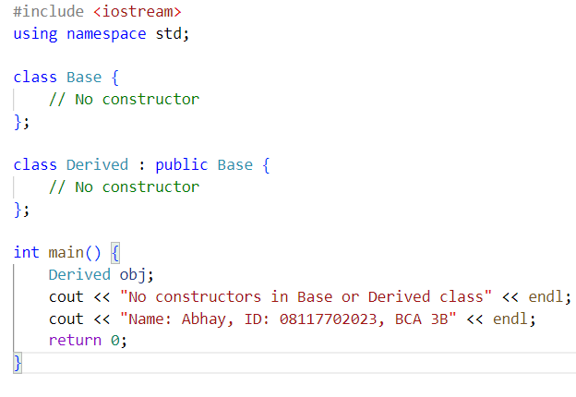

Output:

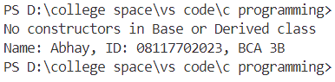

**Program 28:**

Constructor only in base class

Source code:

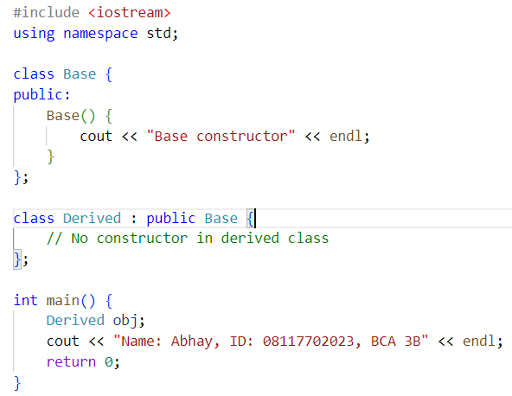

Output:

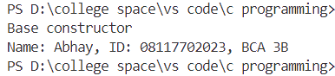

**Program 29:**

Constructor only in derived class

Source code:

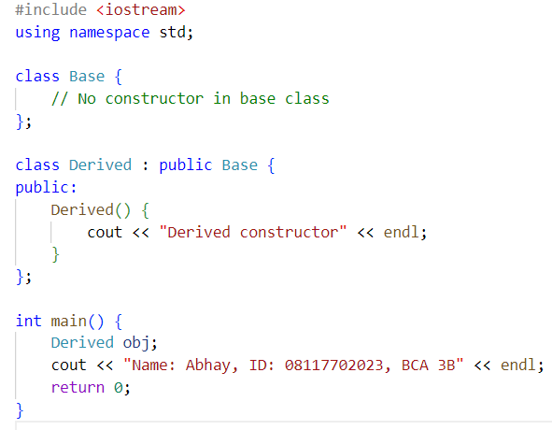

Output:

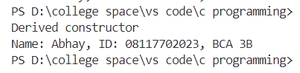

**Program 30:**

Constructor in both base and derived class

Source code:

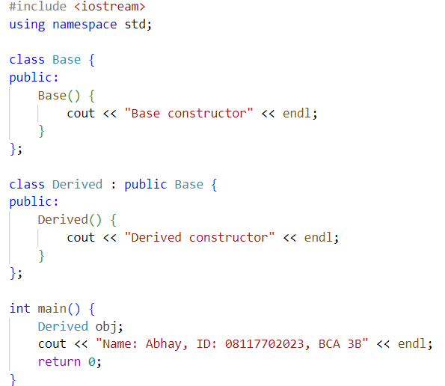

Output:

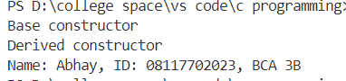

**Program 31:**

Multiple constructors in base class and single constructor in derived class

Source code:

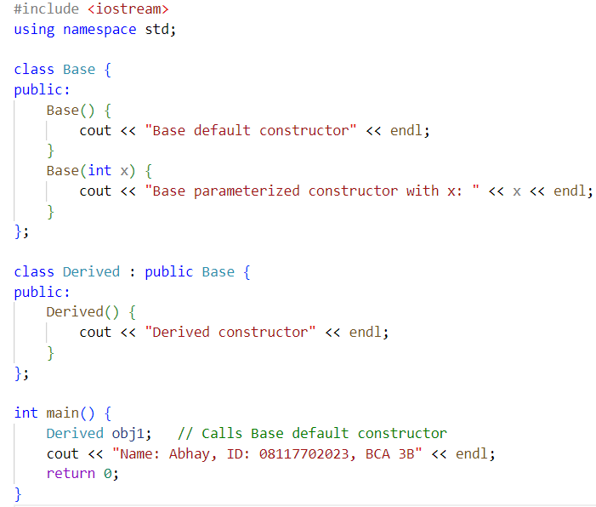

Output:

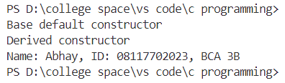

**Program 32:**

Constructor in Base and Derived class without default constructor

Source code:

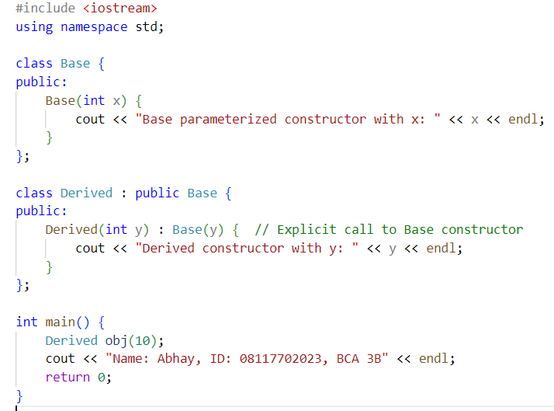

Output:

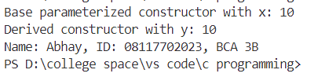

**Program 33:**

Explicit invocation in the absence of default constructor

Source code:

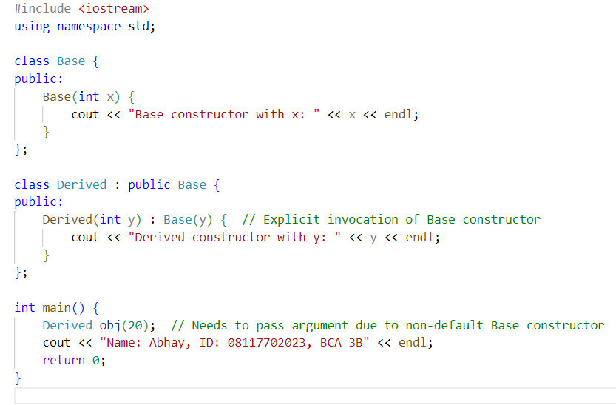

Output:

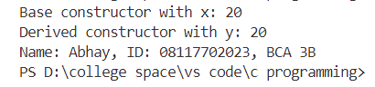

**Program 34:**

Constructors in derived class with multiple inheritance (default invocation)

Source code:

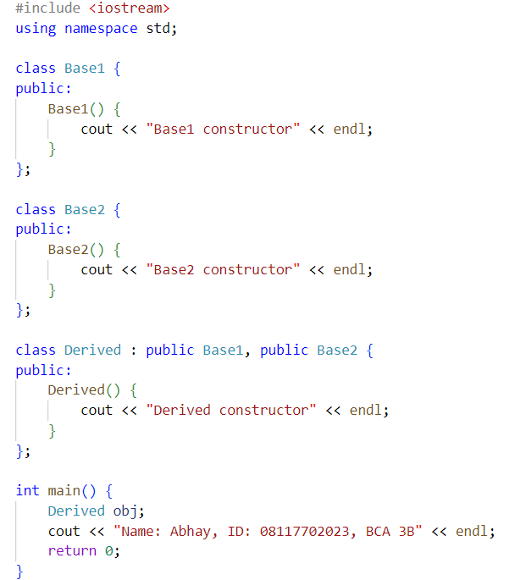

Output:

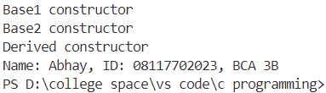

**Program 35:**

Constructors in derived class with multiple inheritance (explicit invocation)

Source code:

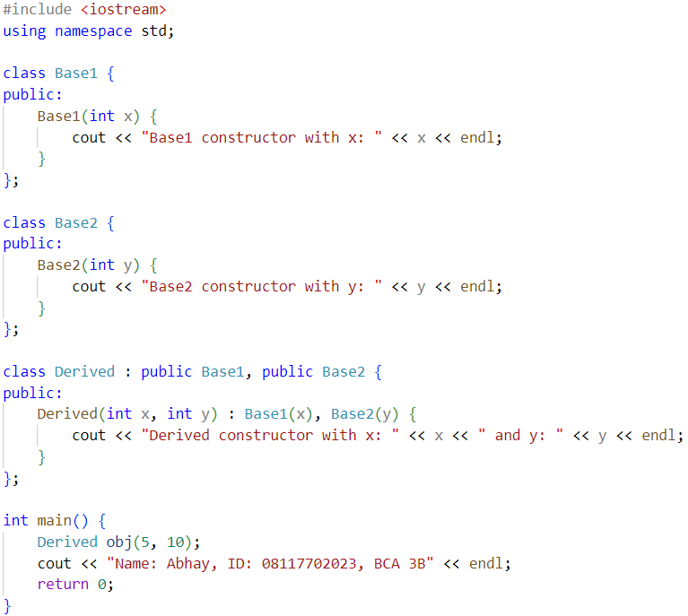

Output:

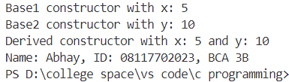

**Program 36:**

Constructors in base and derived classes in multiple inheritance

Source code:

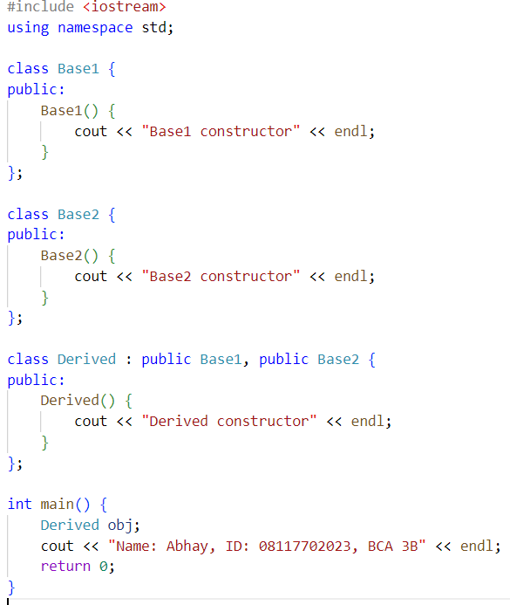

Output:

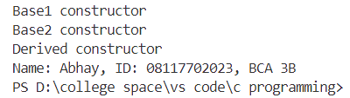

**Program 37:**

Constructor in derived class in multilevel inheritance

Source code:

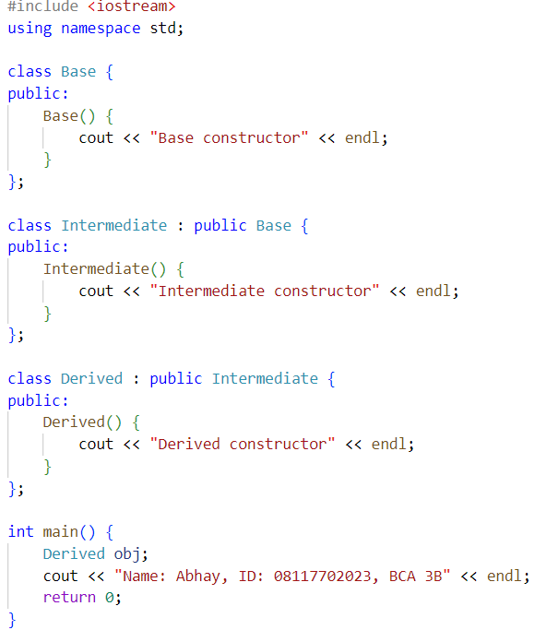

Output:

